CodeAlpha Internship - Task 4: Network Intrusion Detection System (NIDS)
Author: Tinotenda Jaine Chikomo
Date: October 2026

1. Project Overview
The objective of this task was to setup,configure and deploy a Network-based Intrusion Detection System (NIDS) using Snort or Suricata to actively monitor network traffic and detect potential threats then implement response mechanisms for the detected intrusions. The deployment was executed natively on a Windows environment (HP Elite Book) to overcome virtualization network bridging limitations, successfully intercepting live traffic.

2. Environment Setup & Interface Identification
The first step was to verify the Snort v2.9.20 installation and identifying the correct network adapter. Using the command prompt, the network interfaces were mapped, and the Intel(R) Dual Band Wi-Fi adapter (Index 4) was selected for packet capture.

Step | Action / Command | Details
01 | Verify Snort Installation | snort -v
02 | List Network Interfaces | snort -W
03 | Target Interface Selection | Index 4 (Intel Dual Band Wi-Fi)

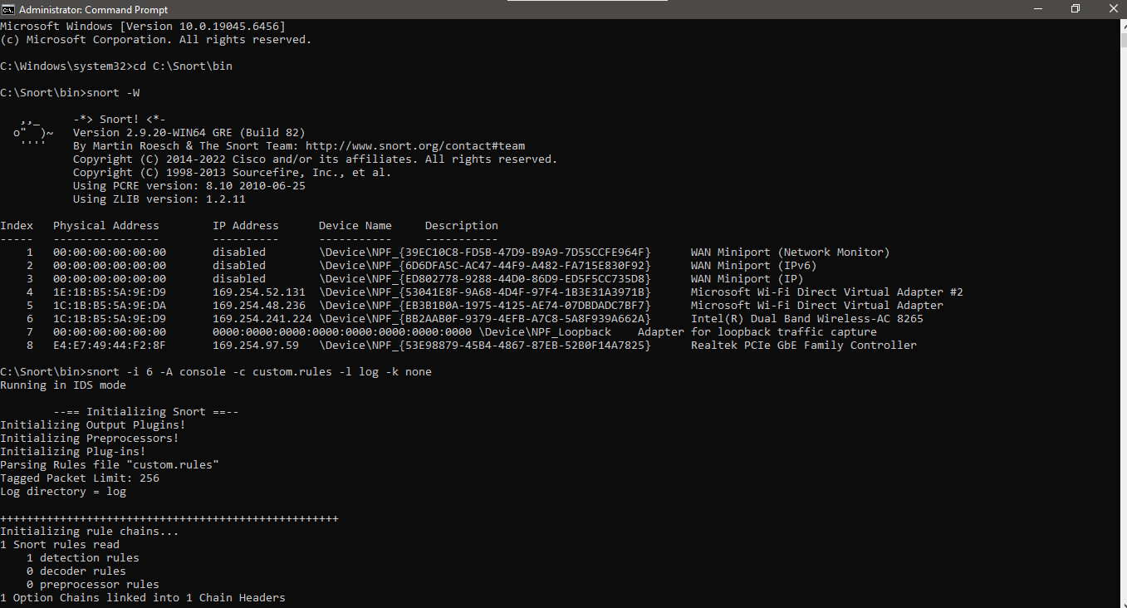

3. Configuring Custom IDS Rules
A custom signature rule was engineered to actively flag specific network reconnaissance attempts. A local rules file (custom.rules) was created to instruct Snort to monitor and alert on any incoming ICMP echo requests (pings).

Rule Syntax Used:
alert icmp any any -> any any (msg:"Ping Detected"; sid:1000001;)
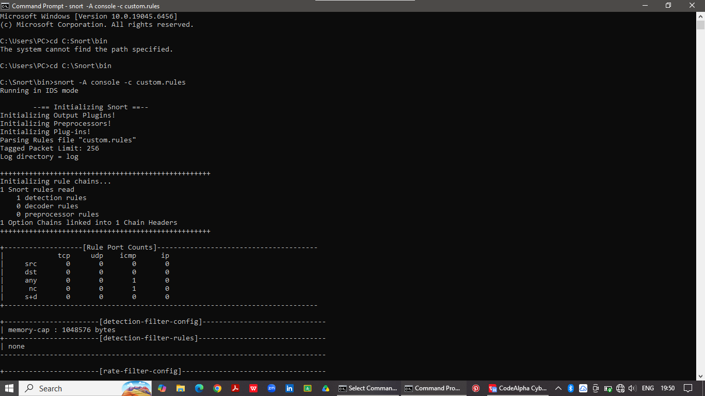
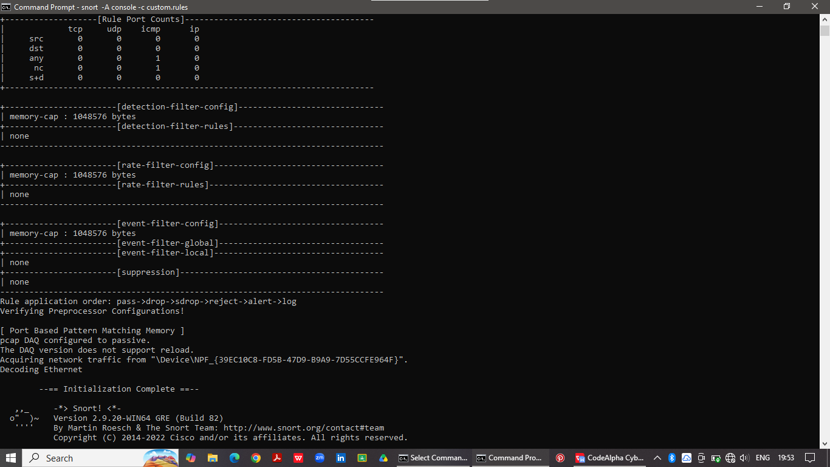

4. Initializing Active Threat Detection
Snort was transitioned from a passive sniffer into an active Intrusion Detection System. It was bound to the Wi-Fi interface and instructed to output alerts directly to the console using the following command:

snort -A console -c custom.rules -i 4
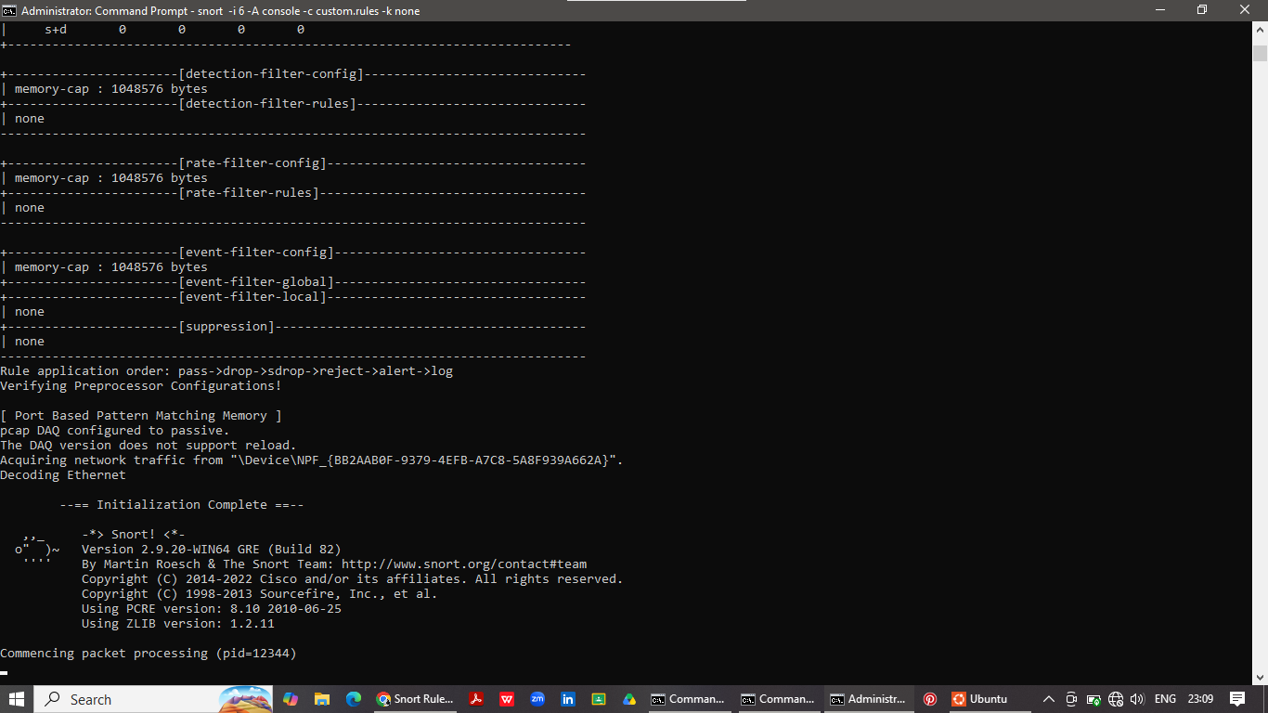

5. Threat Simulation and Alert Verification
To verify the IDS functionality, a secondary command terminal was opened to simulate network reconnaissance by sending ICMP traffic (ping 8.8.8.8). Snort successfully matched this live traffic against the custom rule signature, generating real-time warnings.

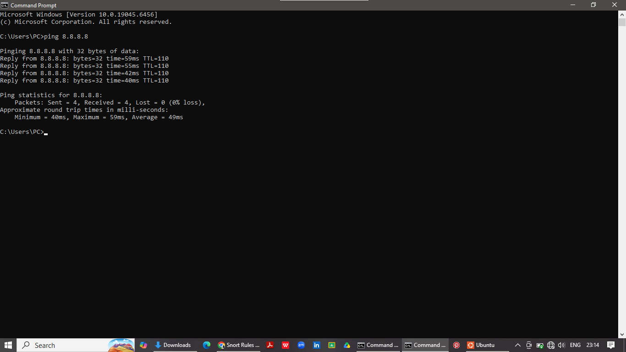

6. Conclusion
Deployed the Snort NIDS successfully. The system demonstrated the ability to read custom rule configurations, bind to the local network adapter, and dynamically identify and alert on specific network behaviors in real-time, completing the objectives of Task 4.

